
MARIST GOLF DAY: FOUR-BALL ENTRY FORM

DATE: Thursday, 4 June 2026
VENUE: Royal Durban Golf Club
FORMAT: Four-Ball Alliance (2 scores to count)

EVENT SCHEDULE & DETAILS
- Registration: From 09h00
- Tee-off Times: 10h30 – 12h00 (Please be at your allocated tee box 10 minutes prior)
- Prize-Giving & Dinner: To commence immediately after the final Four-Ball finishes.
- Entry Fee: R3 200 per Four-Ball
  - Includes: Green fees, post-round meal, a FREE 1-hour practice session (unlimited balls) at the Indie Golf University Golf Centre, and a 10% Indie Golf discount voucher.
  - To book your practice session, WhatsApp 068 094 1948 with the reference: "St Henry’s + [Your Name]".

Note: Caddies, golf carts, and push carts are for your own account. Carts are limited; please book directly with the Royal Durban Pro Shop at 031 309 1530.

CONTACT INFORMATION
Company/Team Name: ________________________________________________

Contact Person: _______________________ Cell: __________________________

Email: _________________________________ Tel: ________________________

PLAYER DETAILS
Handicap Rule: Official handicaps capped at 24. Unofficial golfers play off a maximum of 18. All scores will be audited by the club.
Player | Surname | First Name | Handicap | Email Address | Cell Number
1
2
3
4

PAYMENT OPTIONS
1. EFT Payment * Bank: ABSA (Pavilion)
- Branch Code: 632005
- Account No: 710579504 (Cheque)
- Reference: [Your Name/Company] + Golf Day

2. ZAPPER Scan the QR code below to pay via the Zapper app:

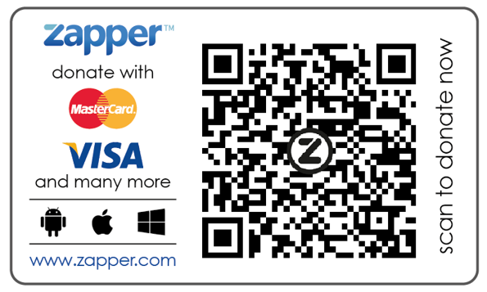

SUBMISSION & QUERIES
Please email your completed form and company logo (for social media branding) to Tessa Tostee: alumni@sthenrys.co.za.

For assistance, contact:
- Tessa Tostee: 083 381 3911 / alumni@sthenrys.co.za
- Kerryn Irving: 031 261 7369 / k.irving@sthenrys.co.za
- Tessa Swart: 031 261 7369 / t.swart@sthenrys.co.za

Thank you for your support—together we can make a difference!

